University of Texas at Dallas
Program in Geographic Information Sciences
Discriminating Urban & Rural Vegetation

By Caiyi Zhong
Instructor: Fang Qiu

1. Introduction & Problem Statement

Vegetation, which is an important class of land cover, is usually cited and studied in classification studies. However, problem occurs in traditional supervised or unsupervised classification methods: urban and vegetation pixels are quite messed up in certain area of the image.

Such problem can be especially obvious in high-resolution remote sensing images. Even a single tree can occupy a number of pixels. We cannot simply classify the tree that are planted in the center of a street as “vegetation”.

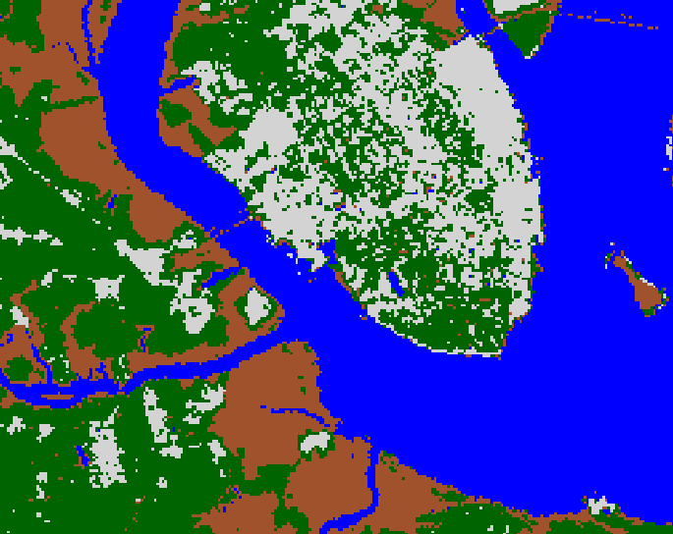
Figure 1. A sample result of unsupervised classification on remote sensing image (not high-resolution)

The objective of this article is to discriminate urban vegetation and rural (or wild, non-urban) vegetation in high-resolution remote sensing images.

2. Literature Review

Existing studies related to this topic is mostly studies about urban vegetation, or urban greening. There is an existing study of urban vegetation classification in Berlin by Jan Tigges, Tobia Lakes, and Patrick Hostert. But this study is mainly discussing the eight frequent tree genera in Berlin, and have nothing to do with discriminating urban vegetation from non-urban vegetation.

3. Data Sources

Sensor: OrbView-3
Data Provider: USGS
Location: Tuzla, Bosnia Hercegovina
Date: Feb. 24th, 2004
Entity ID: 162681
USGS Entity ID: 3v040224m0000286421a520000100082m_001667695

To make debugging faster and easier, I clipped out a small area out of the whole image.

Analysis and Methodology

4.1. Tools

- Microsoft Visual Studio 2012

VS2012 is a omnipotent that provides great development solution that empowers teams of all sizes to design and create compelling apps to delight users. In my case I use this to make C++ program.

- Geospatial Data Abstraction Library (GDAL)

GDAL is a translator library for raster geospatial data formats. I use this within my program to do I/O on raster data. So that I can deploy my own algorithm.

- Intergraph ERDAS Imagine 2013

ERDAS Imagine is our old friend to deal with remote sensing images. Version 2013 makes huge optimization on program performance. But in this project, I just use it to do post-classification. Just as we have done in lab 9 and lab 10.

4.2. Steps

4.2.1. Post-classification

This is just as we did in labs.

To do discriminating on urban and rural vegetation, we must at first pick out all the vegetation class first. Also we need information from other class. For example, we need information of urban pixels to indicate where urban area is, and we also need to recognize closed regions of vegetation to analyze that if it is likely to be within urban area.

It is easy to do this using ERDAS Imagine 2013. Use the unsupervised of supervised tools under Raster tab. Either method is OK.
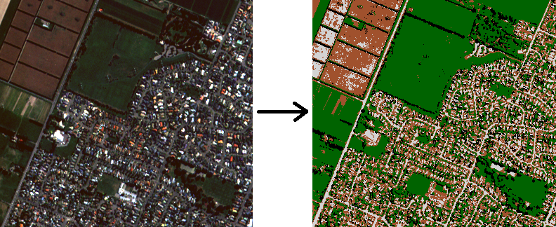
Figure 2. A sample result of unsupervised classification on Tuzla, Bosnia Hercegovina

In the result, we can see shadow because of the high resolution. The shadow class is showed black in the classification result.

However, we can see that shadow is mostly located toward a certain direction. In Figure 2, the shadow lies south-west on its depending object. So we can eliminate shadow by assign shadow pixels to its north-east pixels. Of course shadow aspect can be toward either direction, e.g. north, east, etc. I implemented an 8-direction shadow eliminating algorithm to deal with that.

4.2.2. Removing Shadow

After the preprocessing using ERDAS Imagine, for the rest of the steps, we would start using C++ with GDAL library.

The structure of my C++ project is below:
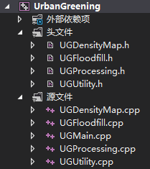

One module is consists of two files: one header file (.h) and one source file (.cpp). Header files contain declarations of functions and classes, and source files contain implementations.

UGDensityMap Module: Urban Density Map (UDM)

UGFloodfill Module: Floodfill algorithm used in the final classification

UGProcessing Module: Contains three major functions: EliminateShadow(), CreateUrbanDensityMap(). and ClassifyVegetation(). Each function stands for a main step of processing.

UGUtility Module: Provides some general functions. Such as copying one raster to another.

The effect of shadow eliminating algorithm can be showed as Figure 3:

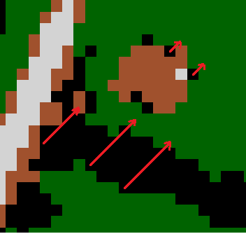
Figure 3. North-east shadow eliminating, to remove south-west shadow pixels

For each shadow pixel, scan along a certain direction (e.g. North-east) until it comes across a non-shadow pixel. Then we can assign a line of shadow pixels to a non-shadow pixel.

Here is a piece of code to do north-east shadow eliminating.

// Scan toward north-east, until meets with a non-shadow pixel
// If scan out of image border, do nothing
do {
x1++;
y1--;
if (x1 >= width || y1 < 0) break;
} while (shadowClassSet.find(buffer[y1 * width + x1]) != shadowClassSet.end());

// If scan out of image border, do nothing
if (x1 >= width || y1 < 0) break;

// Get the class number of the pixel that is found by scanning
classNum = buffer[y1 * width + x1];

// Scan back and assign class number to shadow pixels
x1--;
y1++;
while (shadowClassSet.find(buffer[y1 * width + x1]) != shadowClassSet.end()) {
buffer[y1 * width + x1] = classNum;
x1--;
y1++;
if (x1 < 0 || y1 >= height) break;
}

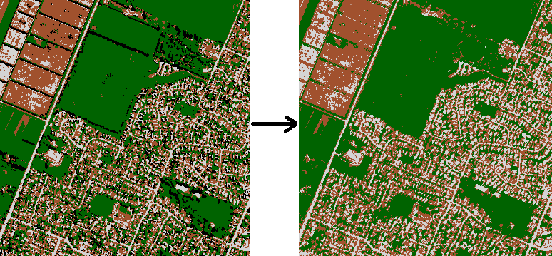
Figure 4. Result of north-east shadow eliminating

But there we may have a issue that on the border of a image, some shadow pixels cannot be replaced. But this issue can only affect a little, so we can just ignore them.

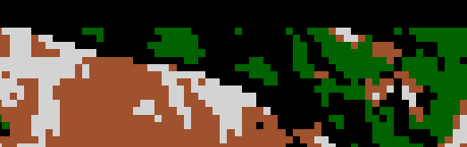
Figure 5. Shadow on the north border cannot be replaced in North-east shadow eliminating.

4.2.3. Creating Urban Density Map (UDM)

UDM is a map that we can get the information about city pixel distribution. In areas that urban pixels are concentrated, the pixel value in UDM is high. On the other hand, in areas that fewer urban pixels appear, the pixel value in UDM is low.

The UDM is created from all urban pixels. Around each pixel is a circle. One UDM pixel can be overlapped by several circles, the number of circle overlapping the UDM pixel then becomes the pixel value.

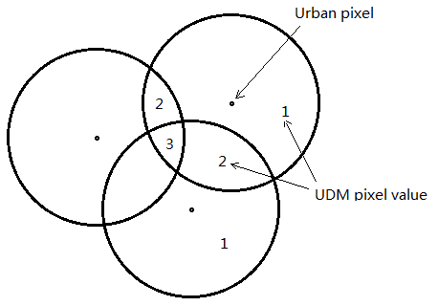
Figure 6. Creation of UDM

The generating of UDM can be divided into two steps. First we generate a window with a certain radius. The window is like a smaller grid like below (radius 3):

0 0 0 1 0 0 0
0 1 1 1 1 1 0
0 1 1 1 1 1 0
1 1 1 1 1 1 1
0 1 1 1 1 1 0
0 1 1 1 1 1 0
0 0 0 1 0 0 0

Compared with calculating distance to each urban pixel when generating UDM, using windows (the window can be generated before UDM generating) saves time.
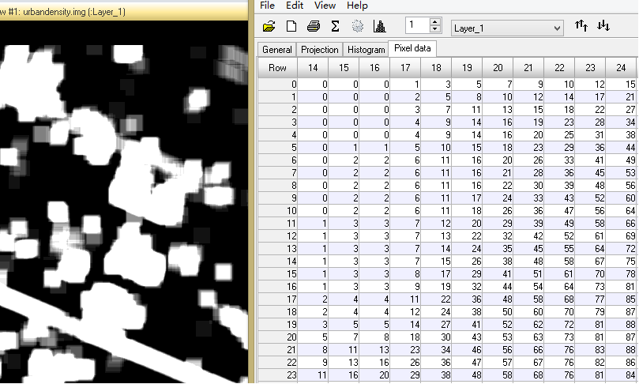
Figure 7. Sample UDM

The image appears not good because I still don’t know how to change the lookup table using GDAL. But the appearance of UDM can be seen more clearly in the table.

4.2.4. Urban / Rural Vegetation Discrimination

Before conducting this step, we must at first keep in mind the characteristics of urban vegetation, which can be the criteria of our classification:

- Relatively small area, also enclosed by other classes.

Then, we can do a traversal among all vegetation pixels. The algorithm might be:

// Iterating each vegetation pixel
if (vegClassSet.find(buffer[cell]) != vegClassSet.end()) {

// If the pixel is located at high value area in UDM
// (means it is more likely to be in urban area)
if (urbanDensity[cell] >= urbanVegThres) {

// Make a copy of current grid to try floodfilling
CopyGrid(buffer, bufferCopy, width, height);

// If the pixel is in an open area
//(floodfilled too many pixels, exceeding the threshold)
// Then abandon the copy, and floodfill this area as rural vegetation
if (floodfiller.FloodFill(bufferCopy, x, y, vegClassSet, urbanVegClassNum, maxFloodCount) == FLOODFILL_EXCEED_MAX) {
floodfiller.FloodFill(buffer, x, y, vegClassSet, ruralVegClassNum, -1);
}

// Or floodfill this area as urban vegetation
else {
CopyGrid(bufferCopy, buffer, width, height);
}

// Count and print the number of area floodfilled
count++;
printf("Filled %d areas.\n", count);

}

// If the pixel is located at low value area in UDM
else {

// Make a copy of current grid to try floodfilling
CopyGrid(buffer, bufferCopy, width, height);

// If the pixel is in an open area
// (floodfilled too many pixels, exceeding the threshold)
// Then floodfill this area as rural vegetation
if (floodfiller.FloodFill(bufferCopy, x, y, vegClassSet, ruralVegClassNum, maxFloodCount) == FLOODFILL_EXCEED_MAX) {
floodfiller.FloodFill(buffer, x, y, vegClassSet, ruralVegClassNum, -1);
count++;
printf("Filled %d areas.\n", count);
}

// Else we do nothing
// For we cannot discriminate that if it is just surrounded by bare soils,
// or it is just located at the low value area in UDM but still in urban vegetation (e.g. the center of a lawn)

}

}

The algorithm refers to flood filling. In this case we need to fill large areas, so simple 4 way recursive method cannot work because it is both time consuming and memory consuming. I used J. Dunlap’s Queue-Linear Flood Fill algorithm, which can be found in the reference.

5. Results and Discussion

After the algorithm executed, the result can be examined using Inquire tool of ERDAS Imagine 2013.

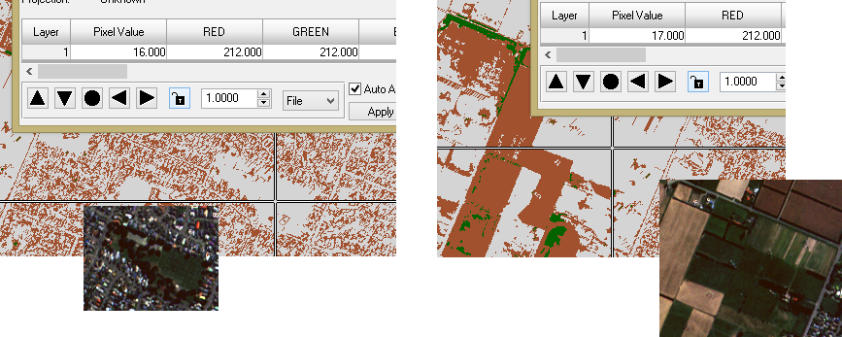
Figure 8. Result (Hard-coded 16 stands for urban vegetation, 17 stands for rural vegetation)

6. Conclusions

It takes me hundreds of lines of code to complete this project.

6.1 Limitations

As I mentioned above, I still don’t know how to operate the lookup table using GDAL, so the appearance of my output image is not good for presentation.

6.2 Things to be improved

Accuracy evaluation needed. And I still need to study into GDAL deeper, to get to know how to operate the color table and improve the appearance of the result.

7. References

[1] Dunlap, J.. Queue-Linear Flood Fill: A Fast Flood Fill Algorithm [EB/OL]. CodeProject. http://www.codeproject.com/Articles/16405/Queue-Linear-Flood-Fill-A-Fast-Flood-Fill-Algorith

